[1]

ToDoList

Assignment 3

Kwangkyu Choi

This project is about implementing photo history on google map based on location using geo-fencing and camera. As instructions say image and current location of user is saved into permanent storage when user takes pictures using camera and display them on google map.

# INTRODUCTION

I implement permissions for using camera, accessing files, and collecting current location information in manifest. When user initially open the app, it asks those permissions. My program has a bug when initially downloaded and opened by being terminated once asking permissions. But after that, it works fine. Another bug found is this app is working fine on virtual machine of pixel 3a(API 27) however, this app does not work on Nexus that I physically have on hand after I deleted whole application at the end of deadline.

# Application Design

First of all, I created default google map activity and get it connected to google map using API key. After that, I added a button to open camera at the bottom of first activity. I placed small image view at the top right to see the picture that is just captured.

If user take pictures, it might not show up right away. The gallery might have to be re-opened or the app has to be re-opened to see entire pictures.

I was not able to load image to each marker. So this app displays just markers at where the pictures were taken. However, it would have been completed showing each picture if I figured how to set marker icon with bitmap.

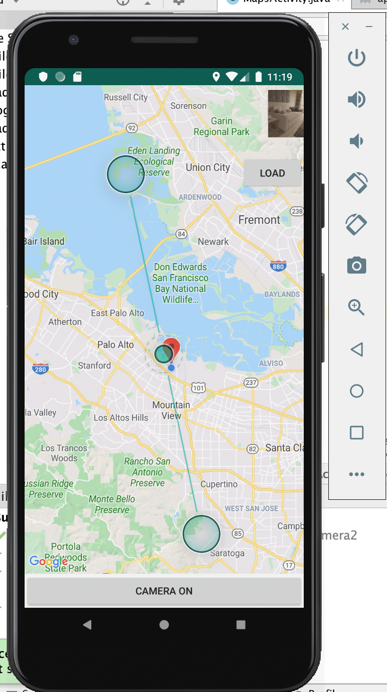

# Results

This app is not perfectly working since it has some bugs that I ignored (initial opening, not working properly on certain device). Also it might seem like not working because either gallery or the app is not being updated automatically. Then user has to terminate apps and re-open them. But the app has most of functions from 1 to 6. Also, I was able to load image from permanent storage to image view. I was not able to associate loading image to marker.

References

1. SREEJITHSREEJITH 63611 gold badge77 silver badges1717 bronze badges, et al. “How to Get the Latitude and Longitude of an Image in Sdcard to My Application?” *Stack Overflow*, 1 June 1963, https://stackoverflow.com/questions/15403797/how-to-get-the-latitude-and-longitude-of-an-image-in-sdcard-to-my-application.

1.